Practical R Activity Six

Association Analysis

Michael Surdek
Southern New Hampshire University
DAT 640: Predictive Analytics
Professor Tom Woolman
February 13, 2022
Association rule mining, particularly when examining a dataset of transactions, “investigates whether two products are being purchased together, and whether the purchase of one product increases the likelihood of purchasing the other.” (Ledolter, 2013) Using the apriori algorithm, every combination of products becomes a potential rule, and they are analyzed based on how often they appear as well as the impact that the appearance of one product has on the likelihood of the appearance of another. Thresholds are set for each evaluation metric, support, confidence, lift, and leverage. The rules that exceed the thresholds can then be used as insights into future transactions.
To execute the apriori algorithm, it is necessary to load the necessary packages, including ‘arules’, and to read in the data set, which is dvdtrans from the rattle package in this example.
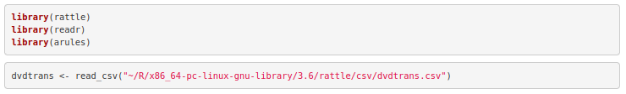
Then, the data must be converted into a transactions structure, where one column indicates the basket and another column contains an item that was purchased in the transaction.
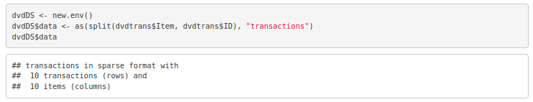
Now, the model can be built with the apriori() function, simply passing the transactions data structure and a list of the desired thresholds for the support and confidence evaluation metrics. The output from this step includes the parameter specifications, the algorithmic control settings, and some details about how long it took to process the apriori algorithm.

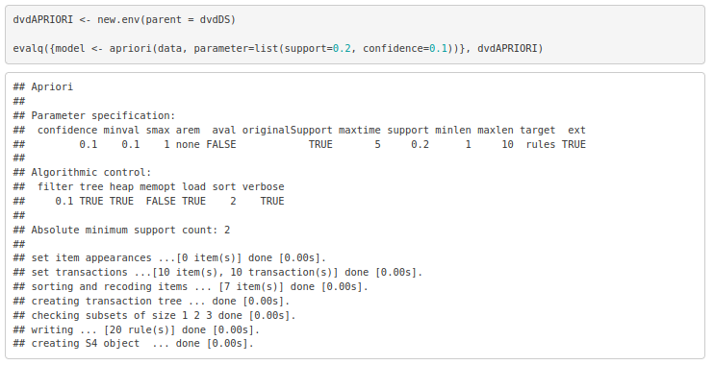
Finally, the inspect function can be used to view the rules that were generated, sorted by one of the evaluation metrics, which is confidence in this case. Here are the top 5 rules from the dvdtrans association anlaysis.
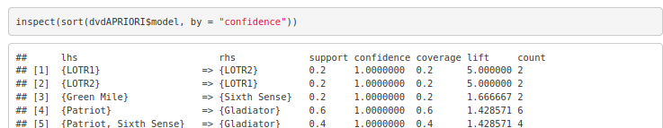
Support is “simply how often the items appear together from amongst all of the transactions.” (Williams, 2011) For example, LOTR1 and LOTR2 both occurred in 20% of the transactions, and Patriot and Gladiator both occurred in 60%. There were 10 transactions total, and the count column shows that 6 of those included both Patriot and Gladiator.
Confidence “is a measure of how often the items C appear whenever the items A appear in a transaction.” (Williams, 2011) This is also known as conditional probability, meaning that given the left hand side of the rule is true, confidence is the likelihood that the right hand side is also true. For each of the top 5 rules, the confidence is 100%. For rule 3, this means that every time Green Mile occurred in a transaction, Sixth Sense was also purchased.
Lift is a tricky but important evaluation metric. It is based on the confidence, but it incorporates the overall support of the rule’s consequent as well. What lift measures is the “increased likelihood of C being in a transaction if A is included in the transaction.” (Williams, 2011) For rule 1, the lift is 5, which means that LOTR2 is 500% more likely to be included in a transaction that contains LOTR1 than a transaction that does not. Similarly for rule 3, Sixth Sense is 167% more likely to be included in a transaction that contains Green Mile than one that does not.

References:

Ledolter, Johannes. 2013. Data Mining and Business Analytics with R. John Wiley & Sons, Incorporated. Retieved from http://ebookcentral.proquest.com/lib/snhu-ebooks/detail.action? docID=1204741.

Williams, Graham. 2011. Data Mining with Rattle and R : The Art of Excavating Data for Knowledge Discovery. Springer New York. Retrieved from http://ebookcentral.proquest.com/lib/snhu- ebooks/detail.action?docID=770229

